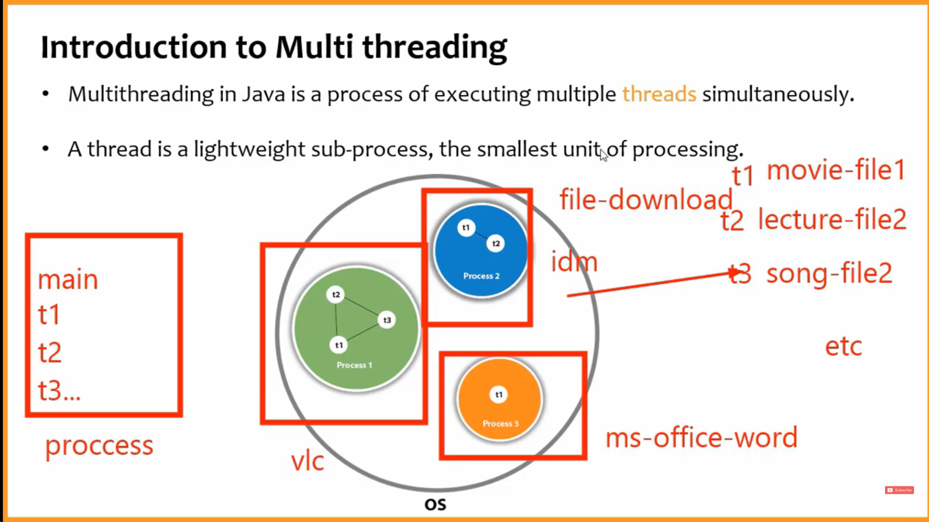

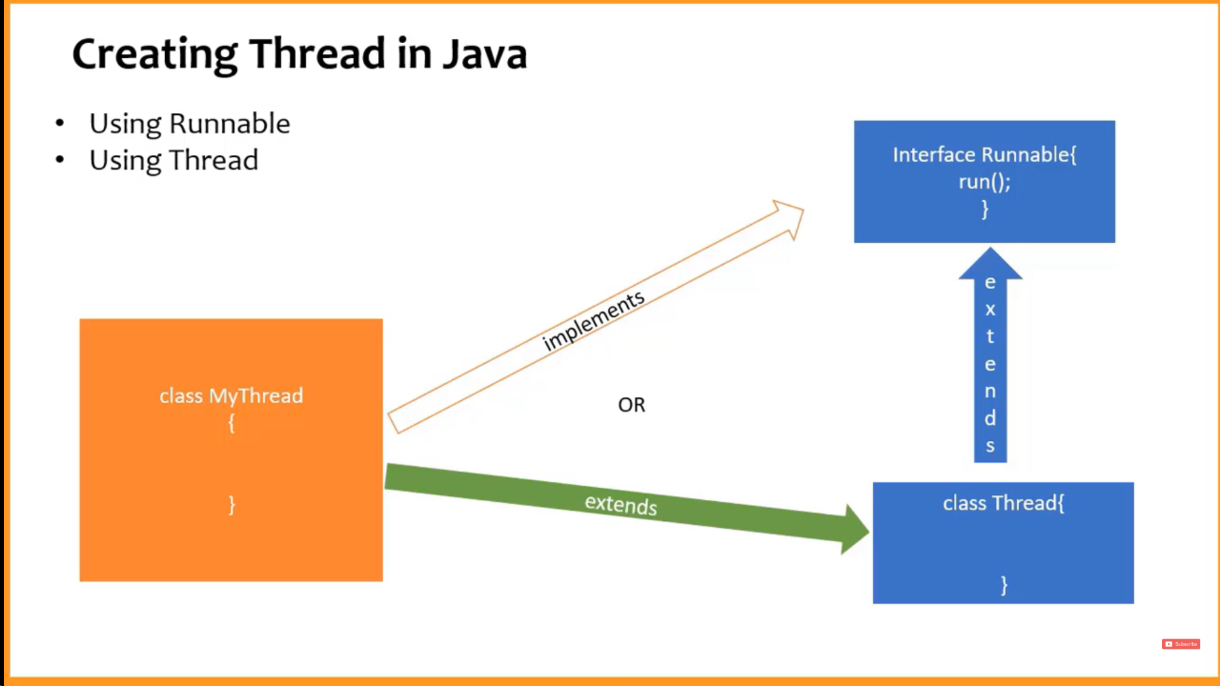

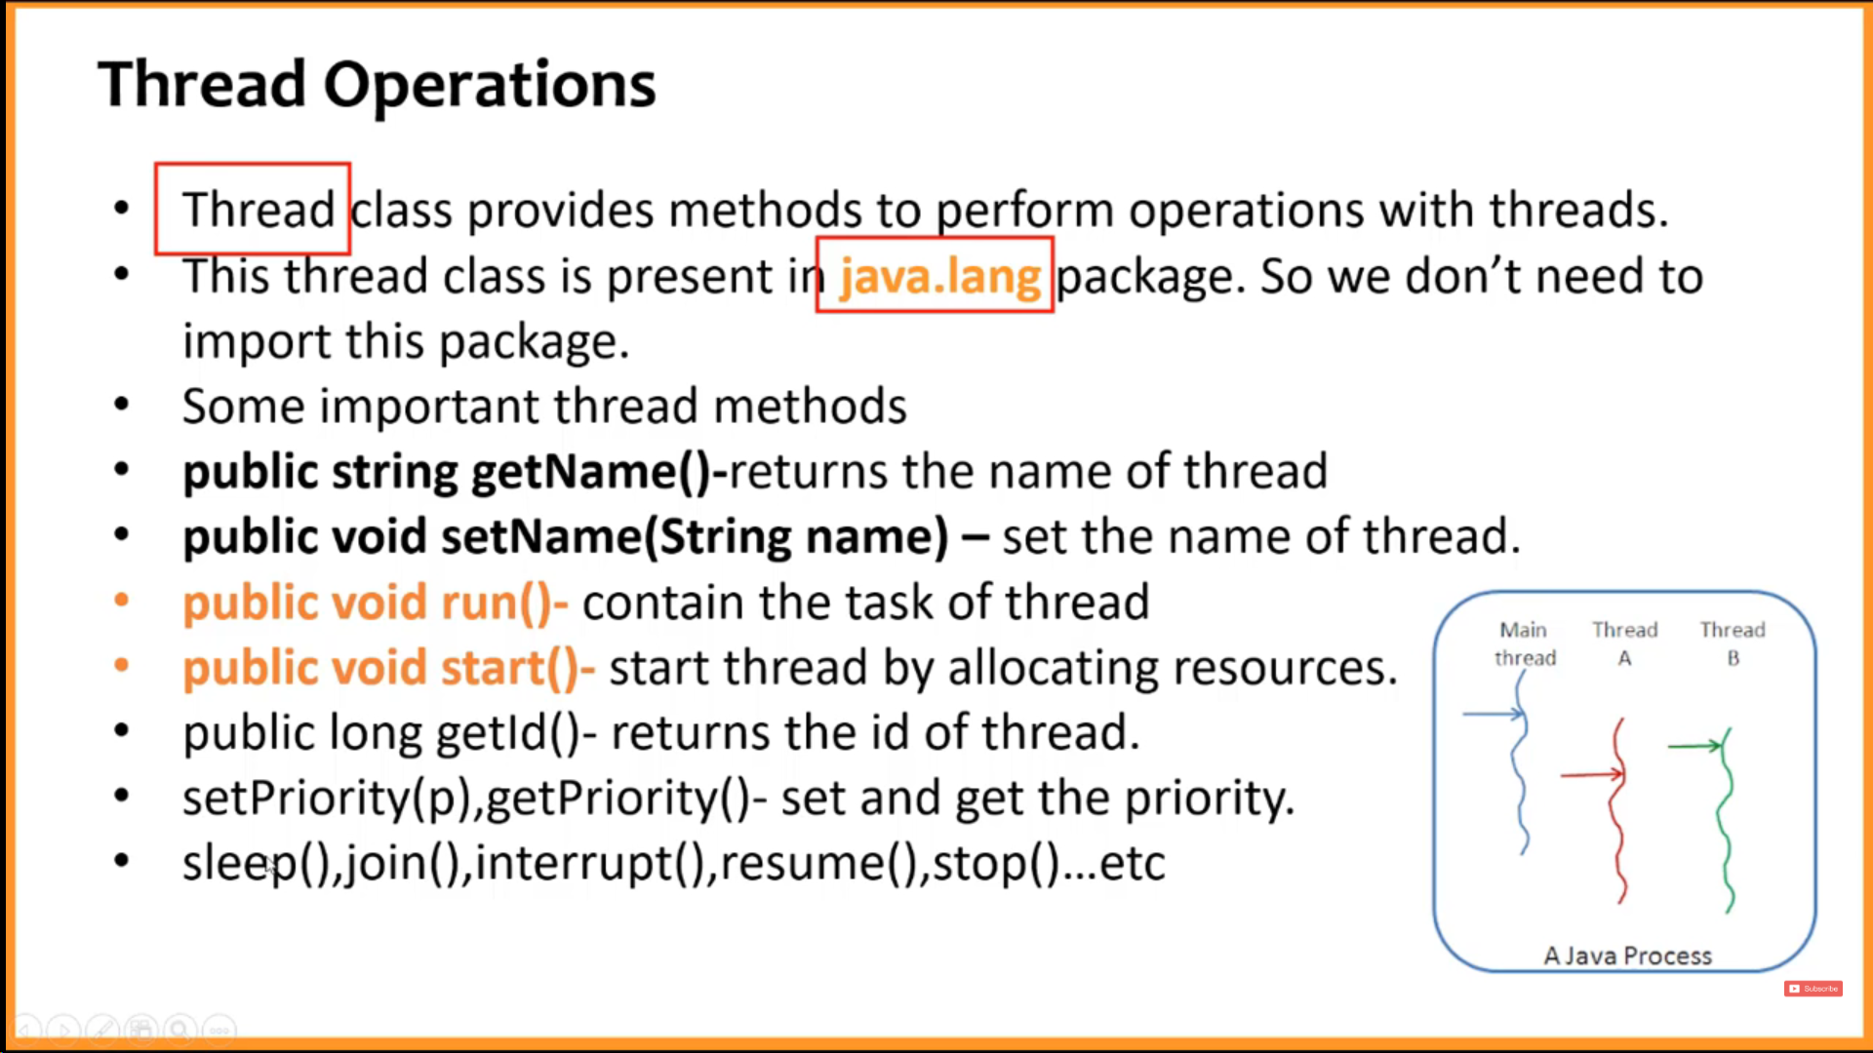

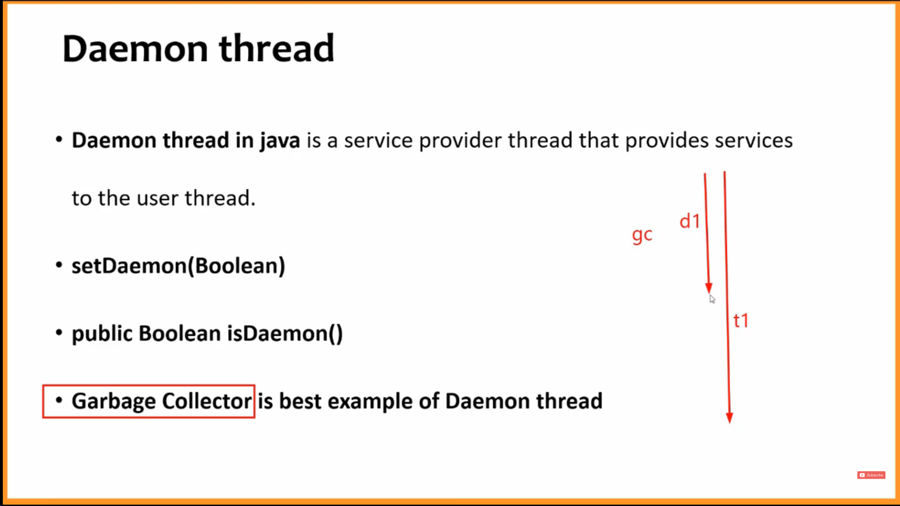

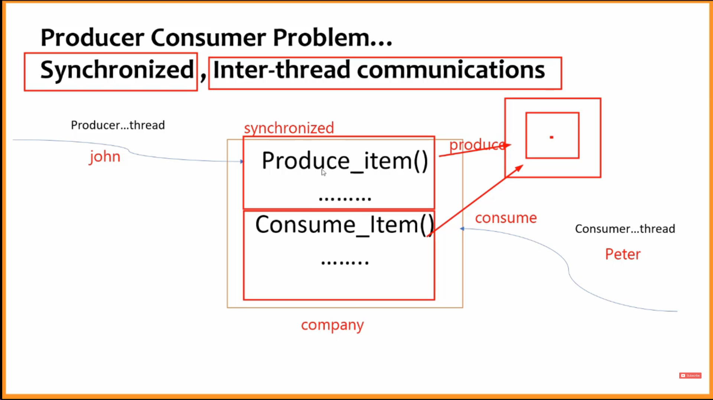

PRODUCER CONSUMER PROBLEM CODE

|  |
| --- |
| **package** com.java.practise;  **class** Main  {  **public** **static** **void** main(String[] args) {  Company comp=**new** Company();  Producer p=**new** Producer(comp);  Consumer c=**new** Consumer(comp);  p.start();  c.start();  }  } |
|  |
|  |
| **package** com.java.practise;  **class** Company  {  **int** n;  **boolean** f=**false**;  // f=false: chance: producer  //f=true: chance :consumer  **synchronized** **public** **void** produce_item(**int** n)**throws** Exception  {  **if**(f)  {  wait();  }  **this**.n=n;  System.***out***.println("Produced : "+**this**.n);  f=**true**;  notify();  }  **synchronized** **public** **int** consume_item()**throws** Exception  {  **if**(!f)  {  wait();  }  System.***out***.println("Consumed : "+**this**.n);  f=**false**;  notify();  **return** **this**.n;  }  } |
|  |
|  |
| **package** com.java.practise;  **class** Consumer **extends** Thread{  Company c;  Consumer(Company c)  {  **this**.c=c;  }  **public** **void** run()  {  **while**(**true**)  {  **try** {  **this**.c.consume_item();    Thread.*sleep*(2000);  }**catch**(Exception e){}  }  }  } |
|  |
|  |
| **package** com.java.practise;  **class** Producer **extends** Thread  {  Company c;  Producer(Company c)  {  **this**.c=c;  }  **public** **void** run()  {  **int** i=1;  **while**(**true**)  {**try**{  **this**.c.produce_item(i);  Thread.*sleep*(1000);}**catch**(Exception e){}  i++;  }  }  } |